Day 18 Intermediate Turtle and the Graphical User Interface

<https://www.udemy.com/course/100-days-of-code/learn/lecture/20236706#overview>

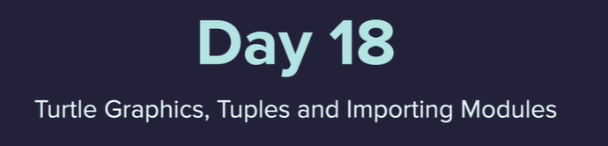

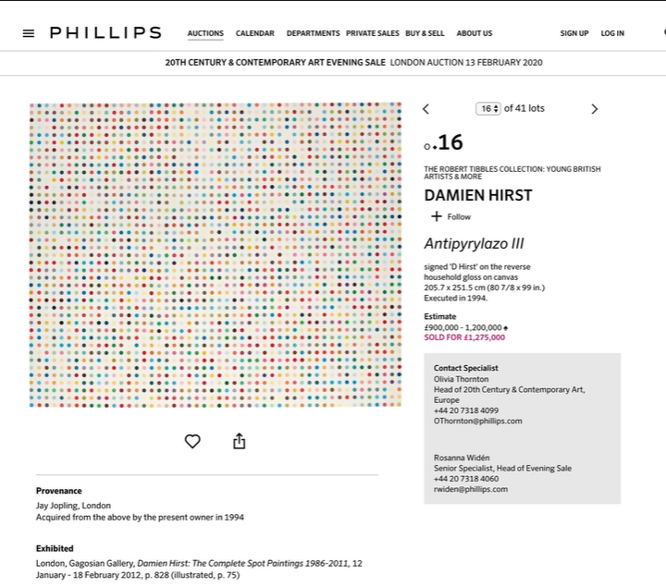

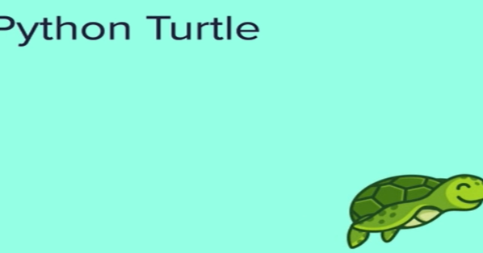

Draw graphics on the screen

<https://docs.python.org/3/library/turtle.html>

<https://cs111.wellesley.edu/labs/lab01/colors>

<https://trinket.io/docs/colors>

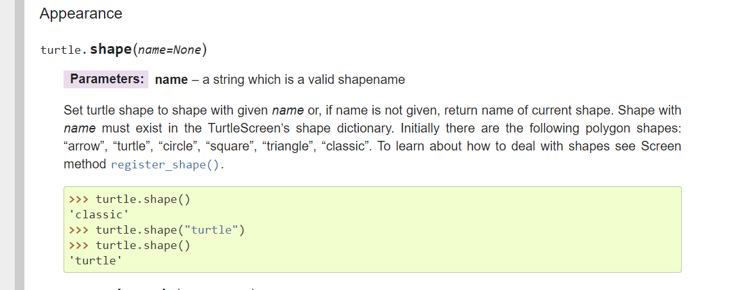

TK colors

<https://www.tcl.tk/man/tcl8.4/TkCmd/colors.htm>

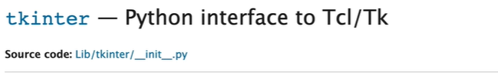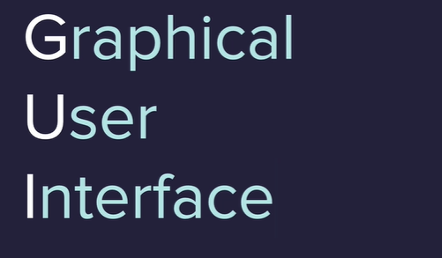

Right click then Refactor > rename to change name in lots of places easily

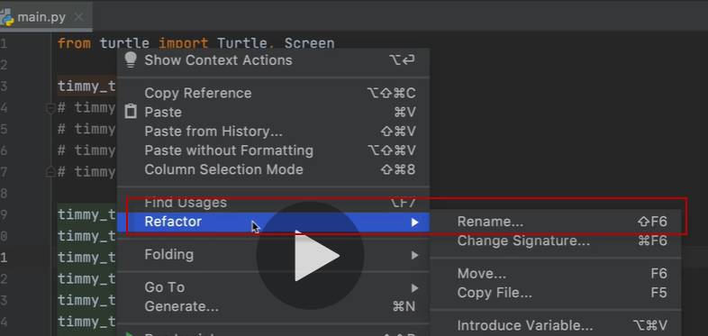





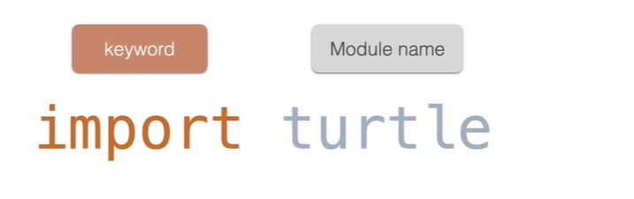

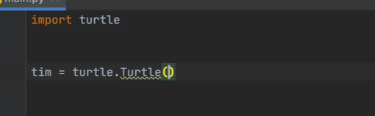

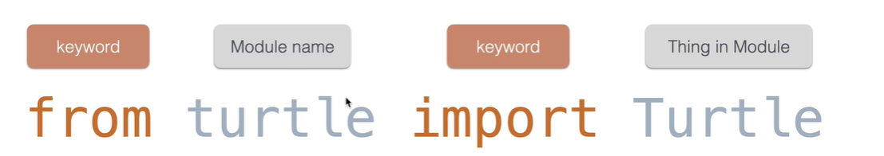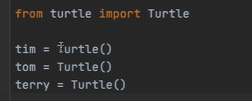

Try to avoid this one as it can be confusing

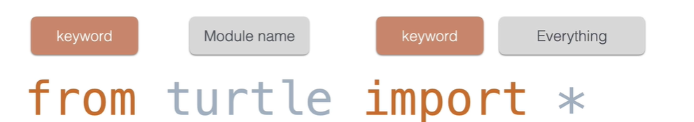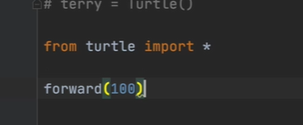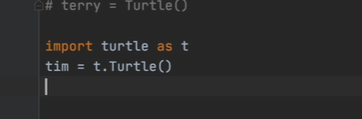

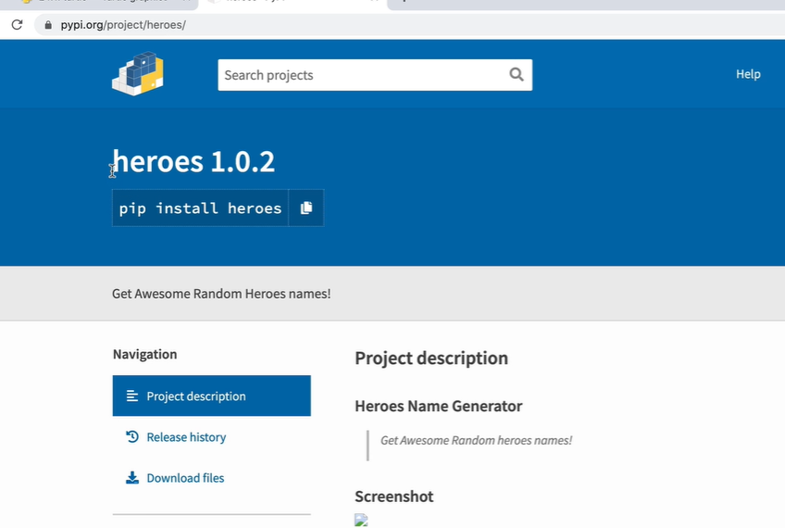

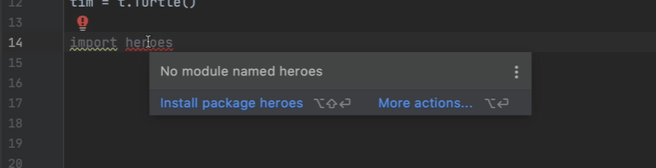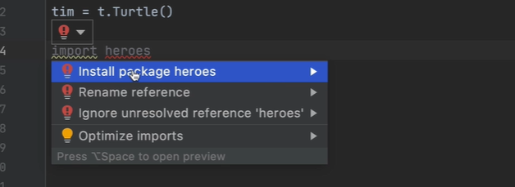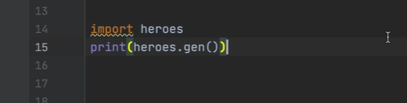

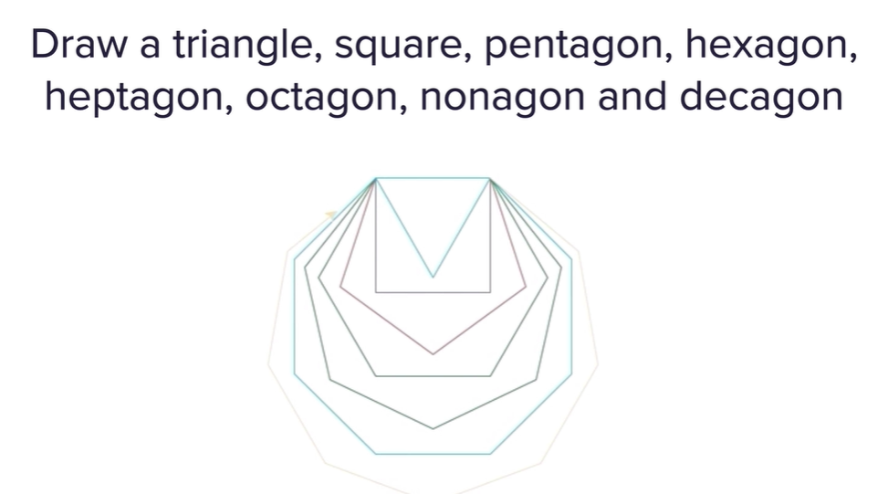

Each side 100 , random color for each

360/number of sides = the angle of turn

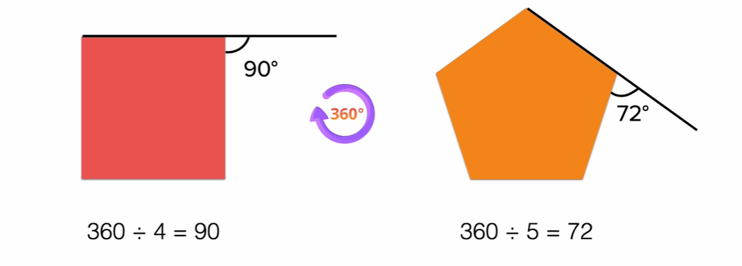

RGB colors

<https://www.w3schools.com/colors/colors_rgb.asp>

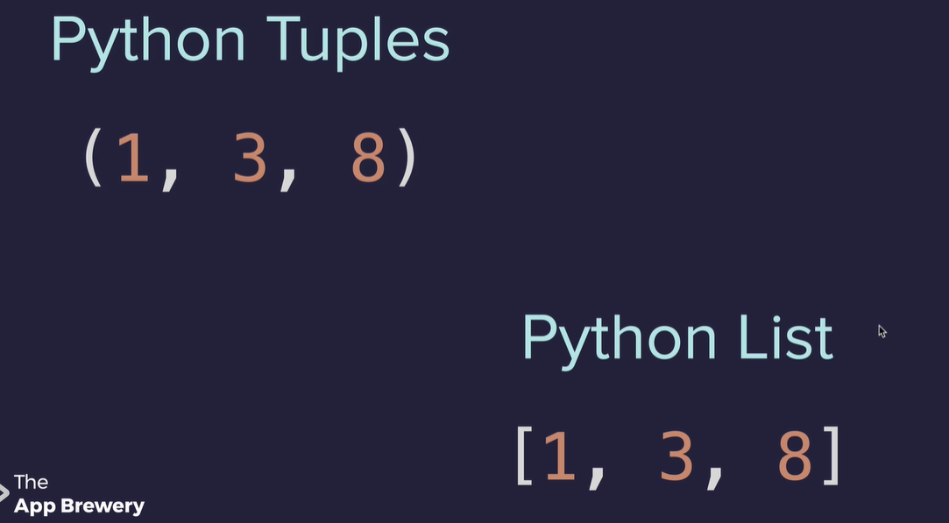

Cannot change the value in the tuple , remove or add items.

A tuple is immutable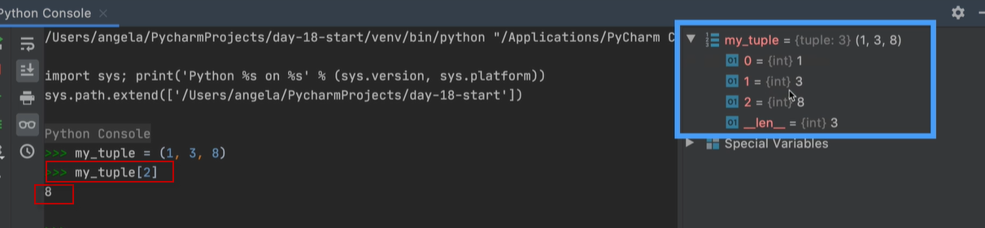

A Tuple can be converted to a list in this way

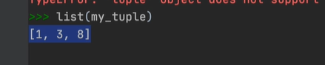



Need to tap into the color module



Then can create a random color

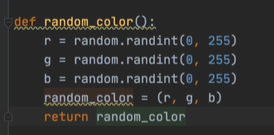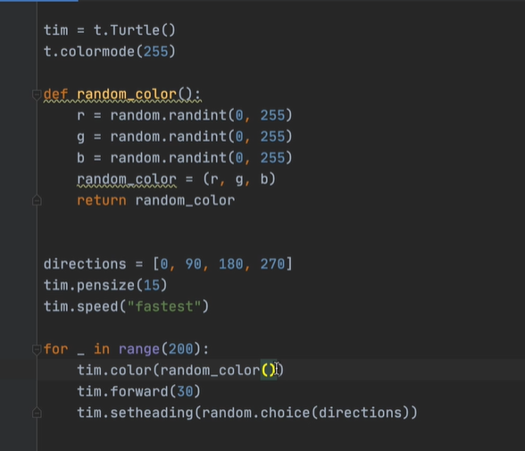

Restart at Spirograph 170

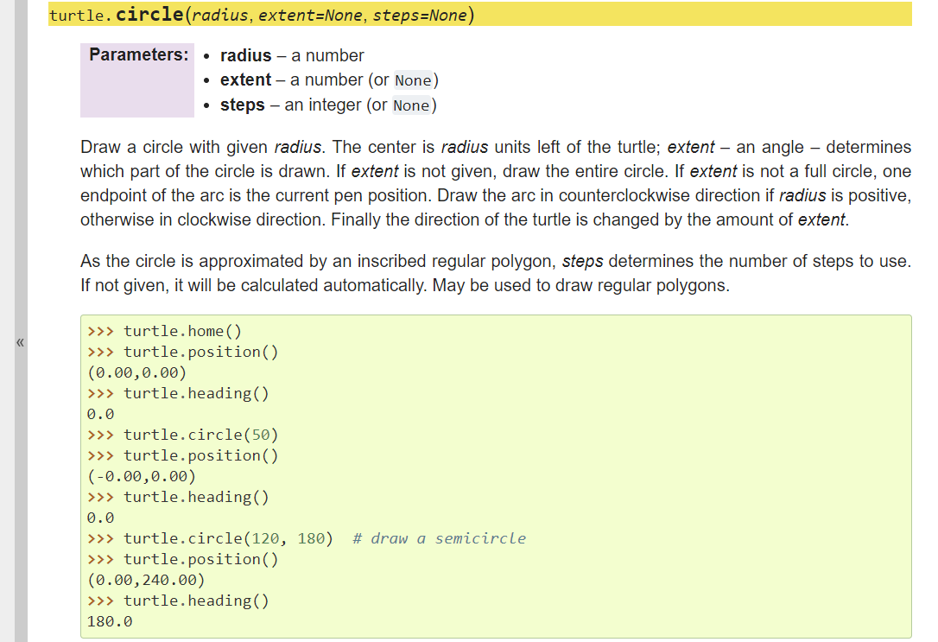

Python colorgram package = extract colors from images – get color pallet

<https://pypi.org/project/colorgram.py/>

here is the JS version of this library

<https://github.com/darosh/colorgram-js>

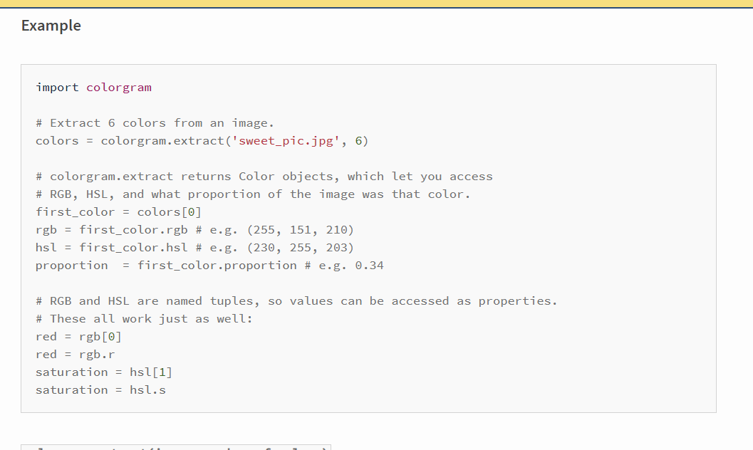

Specs for finial 10 x 10 grid, each dot 20 spaced apart by 50

